Planning and Environment Act 1987

# Maribyrnong Planning Scheme

# Amendment C162mari

# Explanatory Report

## Who is the planning authority?

This Amendment has been prepared by the Maribyrnong City Council which is the planning authority for this Amendment.

The Amendment has been made at the request of Maribyrnong City Council.

## Land affected by the Amendment

The Amendment applies to land in West Footscray and Footscray as outlined in red in Figure 1:

Figure 1: Land affected by Amendment C162mari

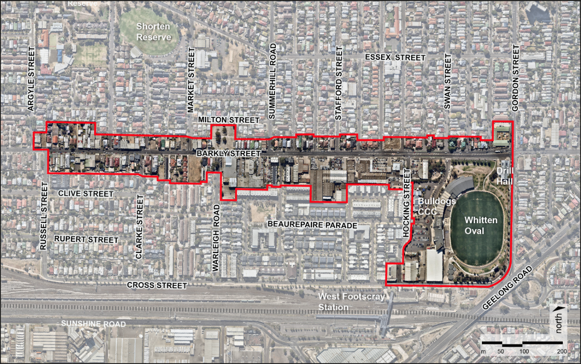

## What the Amendment does

The Amendment implements the land use and built form directions of the West Footscray Neighbourhood Plan (WFNP), prepared in 2018 and updated in October 2022. It extends commercial zonings in the West Footscray Neighbourhood Activity Centre (NAC) and introduces design and development provisions to manage change in the activity centre, Barkly Street East and West Footscray Railway Station precincts.

It also identifies sites of existing or potential contamination and applies provisions to manage their remediation and redevelopment.

The land affected by the Amendment is divided into four main precincts, as shown in Figure 2:

Figure 2: Amendment C162mari Precinct Plan

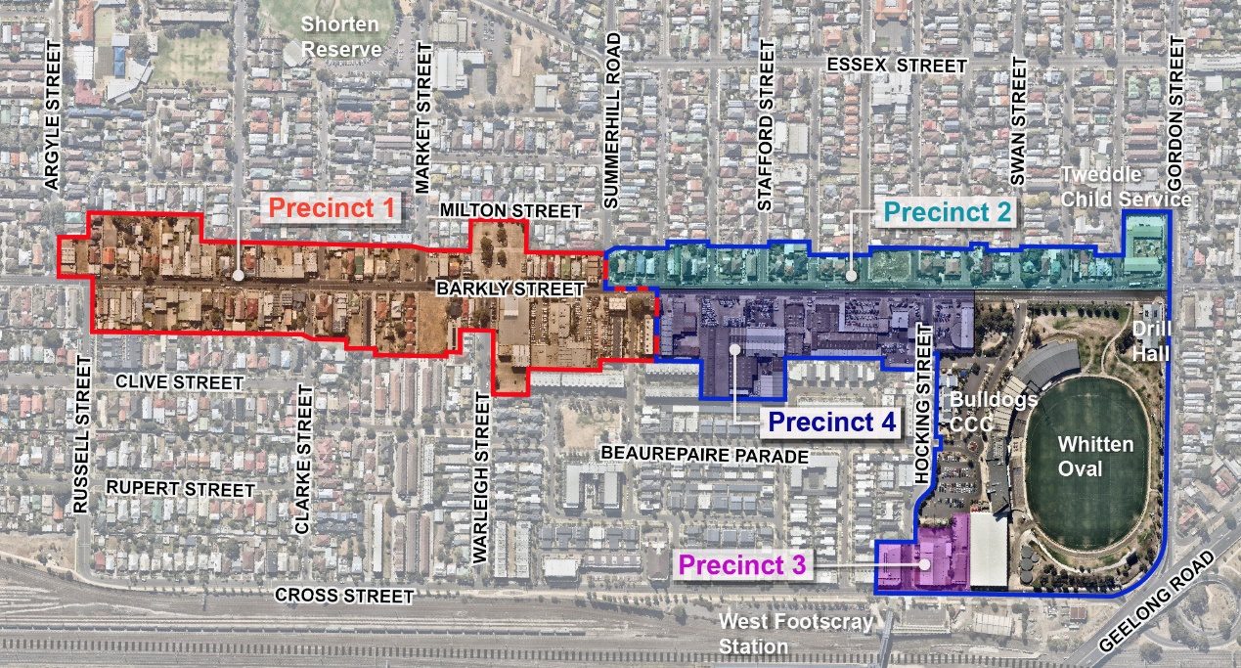

|  |  |
| --- | --- |
| **Precinct 1** | West Footscray NAC. Also known as ‘Barkly Village’. |
| **Precinct 2** | Barkly Street East - northern side  (northern side of Barkly Street between Summerhill Road and Gordon Street) |
| **Precinct 3** | West Footscray Railway Station (4, 6 and 8 Cross Street) |
| **Precinct 4** | Barkly Street East – southern side  (southern side of Barkly Street between West Footscray NAC and Whitten Oval) |

Specifically, the Amendment:

* Amends the Municipal Strategic Statement at clauses 21.01, 21.03, 21,04, 21.05, 21.07, 21.08, 21.11, 21.12 and 21.14 to reflect the WFNP by:
  + Updating land use and built form policy for West Footscray NAC (Precinct 1) to strengthen its role as the focus for retail, commercial and local services with a residential population in integrated apartment developments.
  + Introducing new policy for Precincts 2 and 3 to support uses that complement the NAC and facilitate diverse housing opportunities.
  + Identifying further strategic work on the role of the Mixed Use Zone land in the NAC and providing guidance on the potential transition of Precinct 4 to facilitate a mix of residential and commercial (non-retail) uses.
  + Updating the municipal framework plan maps to align with the WFNP.
  + Including the WFNP as a Reference Document in the planning scheme.
  + Removing redundant references to the West Footscray Urban Design Framework (UDF) 2008 (predecessor to the WFNP).
* Rezones selected land in the West Footscray NAC from the General Residential 1, Mixed Use and Commercial 2 Zones to Commercial 1 Zone.
* Inserts Schedule 3 to the General Residential Zone and applies it to all land in Precinct 2.
* Rezones land in Precinct 3 from the Commercial 2 and General Residential 1 Zones to Mixed Use Zone.
* Revises Design and Development Overlay – Schedule 7 (DDO7) and extends its application include all land in Precincts 1 and 2. This does not apply to:
  + Properties in Precinct 1 affected by the existing Development Plan Overlay – Schedule 10 (481-491A Barkly Street, 22-32 Hewitt Avenue and 45-57 Hewitt Avenue).
  + The rear portion of the supermarket carpark fronting Milton Street in Precinct 1 (comprising Lot 1 on TP742312, Lot 25 on LP700, Lot 24 on LP700, Lot 1 on TP135229 and Lot 1 on TP692860).
* Revises Design and Development Overlay – Schedule 8 and extends its application to include all land in Precinct 3.
* Applies the Environmental Audit Overlay (EAO) to the supermarket site at 509-511 Barkly Street, West Footscray, land at 438-440 Barkly Street, Footscray, and land at 8 Cross Street, Footscray, to ensure sites of existing and potential contamination are suitably remediated prior to sensitive uses being allowed.
* Amends the Schedule to Clause 66.06 (Notification of Permit Applications under Local Provisions) to include a notice requirement to the owner and licensee of Licensed Pipeline No. 18 of development applications in Precinct 1 and 2 within 27 metres of the gas pipeline.

The Amendment also corrects a mapping anomaly by rezoning 45 Hewitt Avenue, Footscray, to Mixed Use Zone in its entirety to ensure it is not unnecessarily affected by two residential zones.

## Strategic assessment of the Amendment

## Why is the Amendment required?

The Amendment is required to implement the land use and built form directions of the WFNP, which was prepared by Council in 2018 to guide growth and development of the area. It is premised on the vision of a 20-minute neighbourhood, where people can gather, socialise, shop, work, live and make use of community and leisure services without having to travel far.

The Amendment implements the WFNP by:

* Reconciling the segmented zoning pattern in the West Footscray NAC to expand and focus retail and commercial opportunities and strengthen street level activity.
* Updating local policy to reflect the strategic direction of the WFNP and remove reference to the UDF 2008.
* Supporting a diverse mixed of housing types and sizes responding to forecast housing needs and directing higher density apartment forms to preferred locations close to public transport and services.
* Introducing built form controls to provide clear direction for change in the NAC and adjacent precincts, establish a strong coherent character along Barkly Street, enhance the public realm and protect surrounding amenity.
* Providing a framework for the potential transition of land on the southern side of Barkly Street between West Footscray NAC and Whitten Oval, currently used as car yards and service industries (Precinct 4).

The WFNP and West Footscray Economic Assessment for the Neighbourhood Plan, April 2018, form the strategic basis for the Amendment.

## How does the Amendment implement the objectives of planning in Victoria?

The Amendment implements the objectives of section 4 of the *Planning and Environment Act* *1987* by:

* Improving the planning framework around the use and development of land in a neighbourhood activity centre and two adjacent precincts by providing improved guidance for land uses and the design and form of new development.
* Supporting the role and function of the West Footscray NAC and the Footscray Metropolitan Activity Centre by helping to rejuvenate the West Footscray NAC with additional commercial/mixed use sites and an increased residential and worker population while protecting the amenity of adjacent residential areas.
* Ensuring the risks to human health and the environment in relation to sites of existing or potential contamination are managed.

## How does the Amendment address any environmental, social and economic effects?

The Amendment will generate positive environmental, social and economic effects resulting in a net community benefit.

The rejuvenation of the centre through additional worker and residential population will lead to improvements in the economic wellbeing of the community, providing for an enhanced and more vibrant commercial and retail area. Safety will be increased through increased population and high quality development that better interacts with the streetscape and the public realm.

A more vibrant neighbourhood activity centre will result in people’s local needs being met in the centre reducing their reliance on car travel and increasing active and public transport use. High quality urban design and architectural outcomes in new development will complement public realm improvements in the precincts and increase the amenity, safety and attractiveness of the centre.

The Amendment manages potential environmental risk by requiring adverse amenity impact assessments for new development where appropriate and by applying the EAO to sites of existing or potential contamination.

## Does the Amendment address relevant bushfire risk?

The Amendment will not increase the risk to life, property, community infrastructure and the natural environment from bushfire. The affected land is not located in or near a designated bushfire prone area.

## Does the Amendment comply with the requirements of any Minister’s Direction applicable to the Amendment?

The Amendment complies with the requirements of *Ministerial Direction – The Form and Content of Planning Schemes.*

The Amendment complies with the requirements of *Ministerial Direction No. 1 Potentially Contaminated Land* (MD1) by applying the EAO to sites of existing or potential contamination.

The Amendment rezones land at 509-511 Barkly Street, West Footscray, and 8 Cross Street, Footscray, from Commercial 2 Zone thereby facilitating their possible redevelopment for sensitive/residential use in future. These sites are considered potentially contaminated due to historical uses and the nature of groundwater and soil contamination on adjoining land. The application of the EAO to these sites will ensure the appropriate environmental audit process takes place before a sensitive use and development commences.

The Amendment also applies the EAO to a former petrol station at 438-440 Barkly Street, Footscray. An audit undertaken in 2016 found the site to be suitable for high density residential, commercial and industrial uses subject to conditions. If an alternative sensitive use is proposed (e.g. childcare) a new audit would be required, and therefore an EAO has been applied.

In accordance with clause 6(3) of MD1, it is appropriate to defer environmental audit requirements through the EAO in this manner as the rezonings relate to a large strategic exercise and multiple sites in separate ownership.

The Amendment is consistent with and supports *Ministerial Direction No. 9 Metropolitan Planning Strategy* by advancing the following objectives of Plan Melbourne: 2017-2050:

* Direction 1.2 – Improve access to jobs across Melbourne and closer to where people live

Policy 1.2.1 is to “*Support the development of a network of activity centres linked by transport*”

The Amendment supports this policy by expanding commercial opportunities in the West Footscray NAC and facilitating greater density of people residing in and close to the NAC.

* Direction 1.3 – Create development opportunities at urban renewal precincts across Melbourne

Policy 1.3.1 is to “*Plan for and facilitate the development of urban renewal precincts*” and Policy 1.3.2 is to *“Plan for new development and investment opportunities on the existing and planned transport network”*

The Amendment supports this policy by facilitating transition of strategic redevelopment sites on Barkly Street and opposite West Footscray Railway Station, capitalising on improvements to the station.

* Direction 2.1 – Manage the supply of new housing in the right locations to meet population growth and create a sustainable city

Policy 2.1.2 is to “*Facilitate an increased percentage of new housing in established areas to create a city of 20-minute neighbourhoods close to existing services, jobs and public transport*”.

The Amendment supports this policy by facilitating residential growth in West Footscray NAC and adjoining precincts, which are locations well serviced by community facilities, employment and public transport.

Policy 2.1.4 is to “*Provide certainty about the scale of growth in the suburbs*”

The Amendment supports this policy by targeting growth to specified locations and managing that growth with planning provisions based on comprehensive analysis and consultation and that set clear guidance about development heights, preferred character and measures to protect residential amenity.

* Direction 2.5 – Provide greater choice and diversity of housing

Policy 2.5.1 is to *“Facilitate housing that offers choice and meets changing household needs*”.

The Amendment supports this policy by seeking to facilitate integrated apartment development in West Footscray to increase diversity of housing types in the area and respond to forecast population needs.

* Direction 4.3 – Achieve and promote design excellence

Policy 4.3.1 is to “*Promote urban design excellence in every aspect of the built environment*”

The Amendment supports this policy by seeking to strengthen the quality of the public realm in West Footscray NAC and create a strong consistent streetscape character on Barkly Street. By implementing design guidelines in the NAC and neighbouring precincts, it also seeks to facilitate well-designed buildings with a high degree of internal and external amenity.

* Direction 5.1 – Create a city of 20-minute neighbourhoods

Policy 5.1.1 is to “*Create mixed-use neighbourhoods at varying densit*y” and Policy 5.1.2 is to “*Support a network of vibrant neighbourhood activity centres*”

The policies are central to the Amendment, which seeks to implement the WFNP and its vision for West Footscray “as a place where people can gather, socialise, shop, work, live and make use of community and leisure services without having to travel far”.

* Direction 6.1 – Transition to a low-carbon city to enable Victoria to achieve its target of net zero greenhouse gas emissions by 2050

Policy 6.1.1 is to “*Improve energy, water and waste performance of buildings through environmentally sustainable development and energy efficiency upgrades*”

The Amendment supports this policy by requiring new development to demonstrate environmental sustainable design as part of the planning permit process. It also addresses the need to reduce greenhouse gas emissions by encouraging the needs of the growing West Footscray community to be met locally, reducing reliance on car travel and increasing active and public transport use.

The requirements of *Ministerial Direction No. 11 Strategic Assessment of Amendments* have been considered as outlined in this report, while *Ministerial Direction No. 15 The Planning Scheme Amendment Process* has been followed in processing this Amendment.

Council undertook early consultation with the Environment Protection Authority Victoria (EPA) in accordance with *Ministerial Direction 19 Preparation and Content of Amendments That May Significantly Impact the Environment, Amenity and Human Health* (MD19), and followed their initial advice in preparing the Amendment. During public exhibition, the EPA lodged a submission which identified new matters. Council modified the Amendment in response by applying the EAO to a former petrol station site at 438-440 Barkly Street, Footscray (after providing appropriate notice to affected parties). Additional information was also included in this Explanatory Report to address updated requirements in MD1 introduced in August 2021 after the Amendment was exhibited.

## How does the Amendment support or implement the Planning Policy Framework and any adopted State policy?

The Amendment supports and implements the following objectives of the PPF:

* Clause 11 – Settlement by encouraging growth and development of the West Footscray NAC and adjacent precincts. This will provide opportunities for the consolidation, redevelopment and intensification of the existing urban area and better balance neighbourhood character considerations in other areas. Increased supply of land for residential, commercial, retail, recreational, and other community uses will be provided through implementation of the WFNP.
* Clause 13.04S – Contaminated and Potentially Contaminated Land by identifying sites of existing or potential contamination and applying the EAO to manage their remediation before redevelopment.
* Clause 15.01 – Built Environment by implementing improved design and development controls to help create quality urban environments that are safe, healthy, functional and enjoyable with a better sense of place and cultural identity. The Amendment facilitates a 20-minute neighbourhood that gives residents the ability to meet most of their everyday needs within a 20-minute walk, cycle or local public transport trip from their home.
* Clause 15.02 – Sustainable Development by encouraging land use and development that is energy and resource efficient, supports a cooler environment and minimises greenhouse gas emissions through sustainable development.
* Clause 16 - Housing by encouraging housing developments in key redevelopment areas that are integrated with infrastructure and services. The Amendment will facilitate housing diversity and affordable housing closer to jobs, transport and services through sustainable and efficient provision of infrastructure with access to services, public transport, schools and open space.
* Clause 17 – Economic Development by strengthening and diversifying the local economy and facilitating growth in a range of employment sectors, improving access to employment closer to where people live and clustering activities to promote innovation. The Amendment will encourage development that meets the community’s needs for retail, entertainment, office, and other commercial services by planning for an adequate supply of commercial land in appropriate locations. It will also ensure that commercial facilities are aggregated and provide net community benefit in relation to their viability, accessibility and efficient use of infrastructure by locating commercial facilities in or adjacent to the West Footscray NAC.
* Clause 18- Transport by creating a safer and more sustainable transport system, better integrating land-use and transport and coordinating improvements to public transport, walking and cycling networks, as well as land use and development that supports the Principal Public Transport Network (PPTN). The Amendment is consistent with policies to safeguard Melbourne Airport’s operations by requiring new development to be informed by an acoustic report that considers the impact of aircraft noise where appropriate

## How does the Amendment support or implement the Local Planning Policy Framework, and specifically the Municipal Strategic Statement?

The Amendment supports and addresses the following objectives of the LPPF:

* Clause 21.04 – Settlement by providing for forecast housing growth to identified locations and strengthening the West Footscray NAC as an accessible, pleasant and safe place where people can gather, socialise, shop, work, live and make use of community and leisure services without having to travel far. It also seeks to improve linkages and connections throughout the West Footscray NAC, adjacent precincts and residential areas to enable better access to open space, public transport and daily services.
* Clause 21.05 – Environment and Landscape Values by enhancing the landscape character of the West Footscray NAC and adjacent precincts. It also directs urban intensification into designated areas around public transport and services and implements improved provisions for new development to meet environmental sustainability requirements.
* Clause 21.06 – Built Environment and Heritage by implementing environmentally sustainable design, ensuring that new development will assist in reducing greenhouse gas emissions and minimise impacts on storm water quality and better manage water resources. The Amendment makes no change to existing heritage controls in the West Footscray NAC and adjacent precincts.
* Clause 21.07 – Housing by updating the Housing Framework Plan to identify the Barkly Street East and West Footscray Railway Station precincts as substantial change areas to reflect the residential outcomes planned in the WFNP.
* Clause 21.08 – Economic Development by encouraging the growth and development of retail and other commercial uses in the West Footscray NAC.
* Clause 21.09 – Transport by directing residential and commercial growth into areas along the PPTN and complementing the redevelopment of West Footscray Railway Station.
* Clause 21.11 – Local Areas by implementing revised objectives and strategies for the West Footscray NAC and Barkly Street East and West Footscray Railway Station precincts, incorporating the recommendations of the WFNP.
* Clause 21.12 – Reference Documents by updating the clause to insert the WFNP and remove the West Footscray Urban Design Framework 2008, which is the predecessor to the WFNP.
* Clause 21.14 – Further Strategic Work by updating the clause to reflect the strategic work the WFNP has fulfilled and identifying future work to implement the WFNP objectives (i.e. reviewing the role of Mixed Use Zone land in the West Footscray NAC and the zoning and built form controls of land in Precinct 4).
* Clause 22.03 – Potentially Contaminated Land Policy by applying the EAO to identified sites of existing or potential contamination and require remediation before a sensitive use is located on the land.

## How does the Amendment support or implement the Municipal Planning Strategy?

The Maribyrnong Planning Scheme does not contain a Municipal Planning Strategy so this consideration is not relevant to the Amendment. The amendment is consistent with the Municipal Strategic Statement.

## Does the Amendment make proper use of the Victoria Planning Provisions?

The Amendment makes proper use of the Victoria Planning Provisions (VPP) by utilising the appropriate VPP tools (such as the Commercial 1 Zone, General Residential Zone, Mixed Use Zone, Design and Development Overlay and Environment Audit Overlay) and correcting a mapping anomaly to land at 45 Hewitt Avenue, Footscray.

## How does the Amendment address the views of any relevant agency?

Council undertook early consultation with the EPA in accordance with MD19. Their initial advice was followed in drafting the Amendment through the application of the EAO to land considered potentially contaminated (being 509-511 Barkly Street, West Footscray, and 8 Cross Street, Footscray).

During public exhibition, the EPA lodged a submission which raised new matters. In response, the Amendment was modified to apply the EAO to 438-440 Barkly Street, Footscray (following appropriate notice to affected parties), and further information has been included in this Explanatory Report to reflect new requirements in MD1.

During public exhibition, submissions were also received from Melbourne Water, City West Water, Energy Safe Victoria (ESV) and Downer Utilities (on behalf of AusNet Gas Services).

Melbourne Water and City West Water offered their support / did not object to the Amendment.

ESV and Downer Utilities made submissions regarding impact on a licensed gas pipeline intersecting the Amendment area along Warleigh Road, Barkly Street and Summerhill Road (Precincts 1 and 2). In response, Council engaged a qualified pipeline engineer to prepare a Safety Management Study (SMS) in consultation with ESV and Downer Utilities. The SMS recommended notice of future planning permit applications in the Amendment area within 27 metres of the pipeline be required to AusNet (as the relevant service provider) to consider future impact on the pipeline on a case-by-case basis. The DDO7 refers to the pipeline in a decision guideline while the Schedule to Clause 66.06 (Notice of Permit Applications under Local Provisions) has been modified to include the notice requirement.

## Does the Amendment address relevant requirements of the Transport Integration Act 2010?

## The Amendment will have a positive impact on the transport system by reducing reliance on car travel and promoting use of public and active transport modes. This will be brought about through increased ability to live and work locally in the West Footscray NAC and adjacent precincts and enhanced connections between various transport modes to encourage the use of active and public transport.

## Resource and administrative costs

## What impact will the new planning provisions have on the resource and administrative costs of the responsible authority?

The Amendment is unlikely to have substantial impacts on the resource and administrative costs of the responsible authority, as most development on the affected land would already require a permit.

## Where you may inspect this Amendment

The amendment can be inspected free of charge at the Maribyrnong City Council website at [www.maribyrnong.vic.gov.au/AmendmentC162](http://www.maribyrnong.vic.gov.au/AmendmentC162)

And/or

The amendment is available for public inspection, free of charge, during office hours at the following places:

Maribyrnong City Council

Footscray Library

56 Paisley Street

Footscray Vic 3011

The amendment can also be inspected free of charge at the Department of Transport and Planning website at <http://www.planning.vic.gov.au/public-inspection> or by contacting the office on 1800 789 386 to arrange a time to view the amendment documentation.